CS 2301-01 Operating Systems 1

Instructor: Professor Ravichandran Purushothaman

Name: Anonymos

Written Assignment Unit 1

**Fundamental Principles and Functions of an Operating System**

1. Process Management

Function: Process management is a principle that enables the operating system to efficiently manage running programs (processes). Each process is tracked with information (Process Control Block, PCB), and tasks such as CPU allocation, memory management, and process scheduling are handled.

Role: Process management makes multitasking possible, allowing multiple programs to appear to run simultaneously. It prevents resource conflicts and ensures efficient CPU utilization. This enhances the system's responsiveness from the user's perspective.

Citation: "Process management is essential for multitasking and resource allocation, ensuring that multiple applications can run concurrently without interference" (Silberschatz, Galvin, & Gagne, 2018, p. 121).

2. Memory Management

Function: Memory management is a principle that allows the operating system to efficiently allocate and manage system memory. This includes memory allocation and deallocation, virtual memory management, and swapping.

Role: Memory management enables multiple processes to efficiently utilize memory space, ensuring that each process gets the memory it needs. With virtual memory technology, it is possible to use more memory than the physical memory available. This improves overall system performance and allows users to run more applications simultaneously.

Citation: "Effective memory management techniques are crucial for optimizing system performance and enabling the execution of large applications" (Tanenbaum & Bos, 2015, p. 87).

3. Storage (File System) Management

Function: Storage management involves the principles for managing the persistent storage and access of data. This includes creating, deleting, reading, writing files, access control, and directory structure management.

Role: Storage management enables efficient storage and access of data. It provides standardized methods for users and applications to save and retrieve data, ensuring data integrity and security. This simplifies data management and prevents data loss.

Citation: "File system management is fundamental for data integrity and access efficiency, providing a structured way to store and retrieve information" (Stallings, 2018, p. 145).

4. Input/Output System Management

Function: Input/output system management is a principle that manages interactions with hardware devices (disk drives, keyboards, printers, etc.). It involves device drivers, device management, and buffering.

Role: Input/output system management facilitates efficient communication between users and hardware devices. It abstracts device operations, allowing users to use devices without worrying about hardware specifics. This ensures seamless operation of various devices and enhances user experience.

Citation: "I/O system management abstracts hardware complexities, enabling smooth interactions between software and hardware components" (William & Sawyer, 2019, p. 203).

**Installation of a virtual machine**

1. Download UTM

Download the UTM image from the official site (https://mac.getutm.app/).

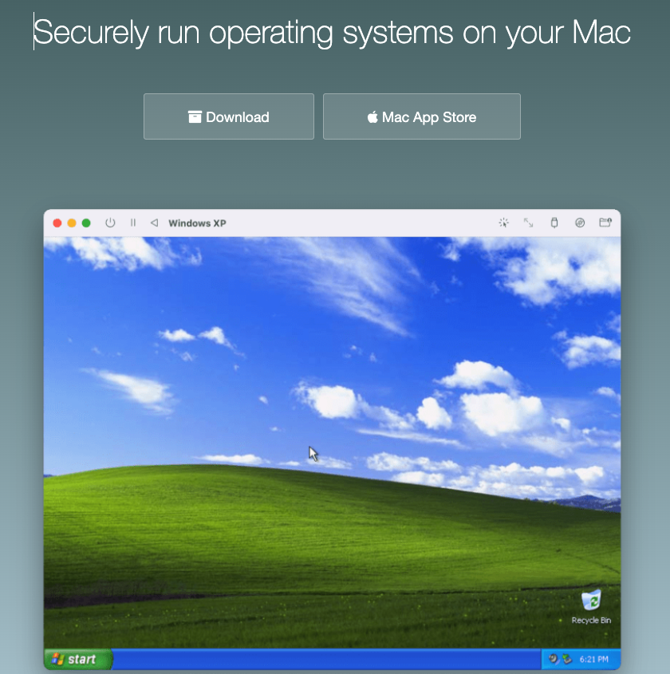

2. Install UTM

Open the downloaded UTM disk image (`UTM.dmg`) and drag the UTM application to the "Applications" folder to install it.

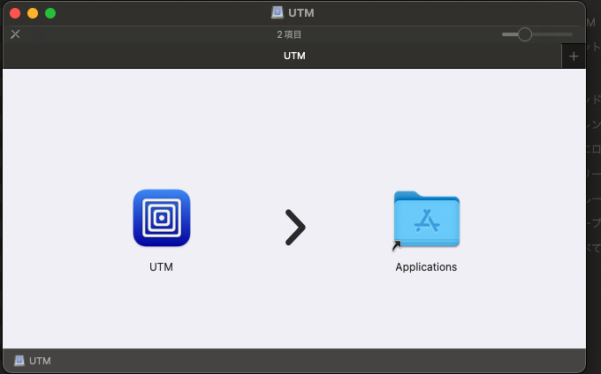

3. Download Linux Distribution

Download an ARM architecture-compatible Linux distribution image. In this case, download [Ubuntu Server for ARM](https://ubuntu.com/download/server/arm).

4. Create a New Virtual Machine in UTM

Launch UTM and click the "+" button in the main window to create a new virtual machine.

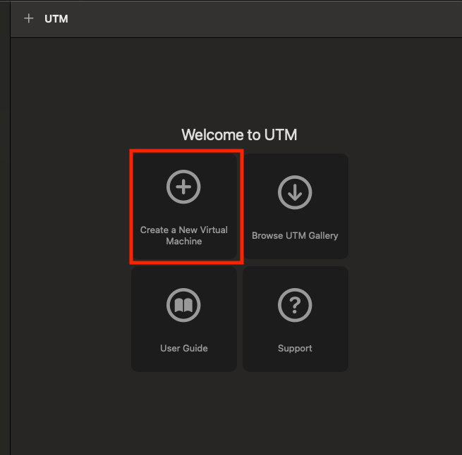

5. Create a New Virtual Machine

Select "Create a New Virtual Machine."

6. Select Virtualize

Choose "Virtualize" and click "Next."

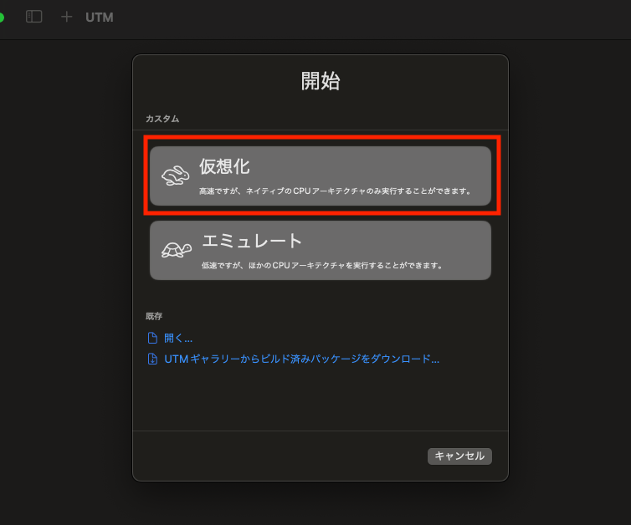

7. Select Linux to Boot Ubuntu

Choose "Linux" and click "Next."

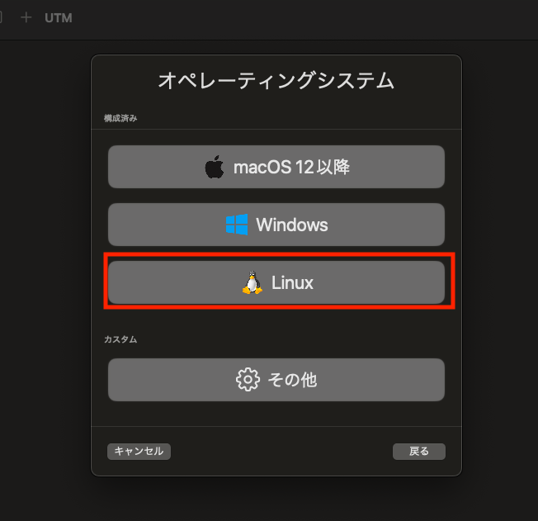

8. Select the Downloaded Ubuntu Image

Click the "Drive" tab, select "Import Drive," and choose the downloaded Ubuntu ISO image.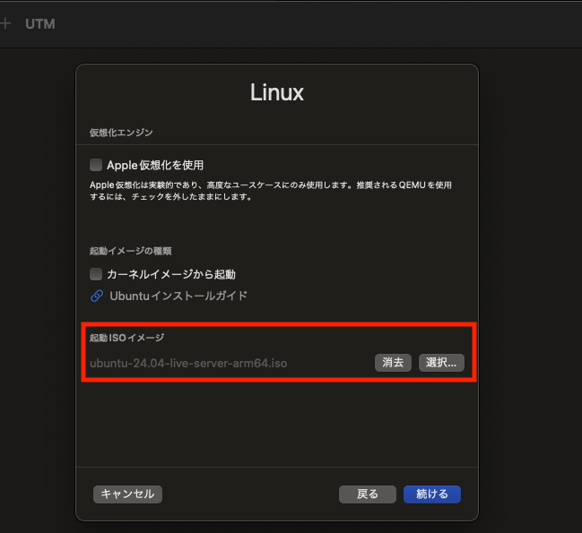

9. Determine the Memory and CPU Cores to Allocate to the Virtual Machine

Set the memory to 4,096MB and the number of CPU cores to 4.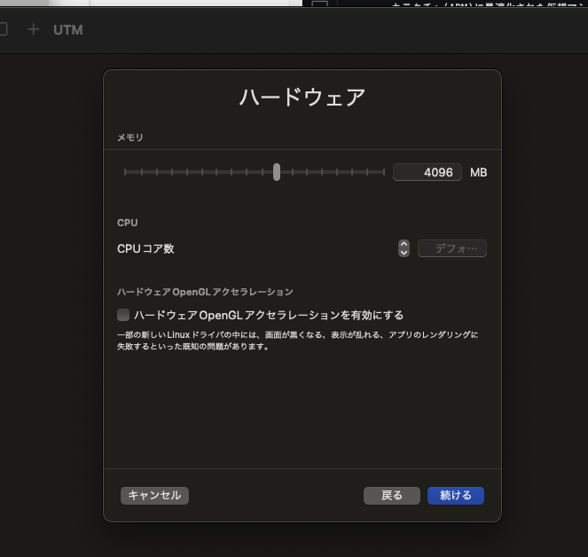

10. Determine the Storage Capacity to Allocate to the Virtual Machine

Set the storage capacity to 64GB.

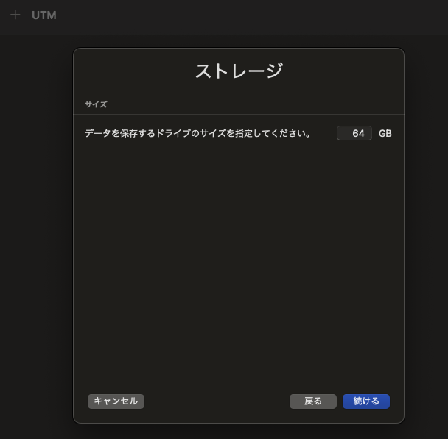

11. Name and Save the Virtual Machine

Enter a name for the virtual machine (e.g., Ubuntu ARM) and save the settings.

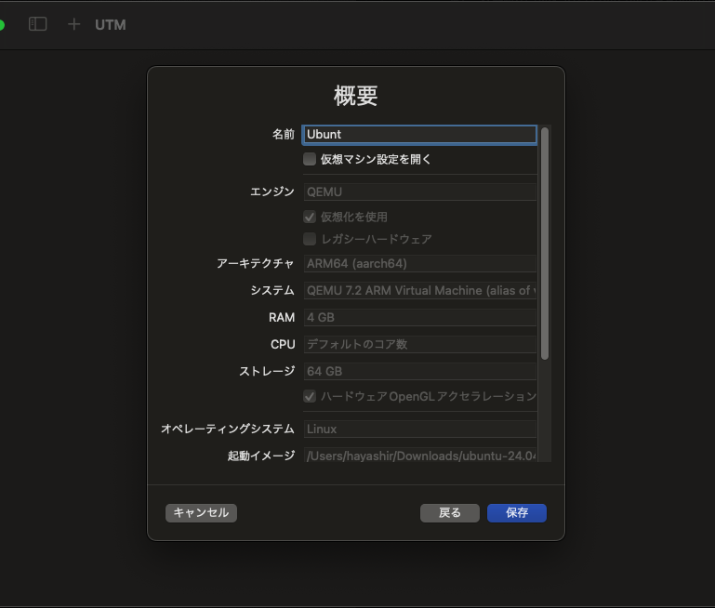

12. Confirm the Saved Virtual Machine is Listed and Start It

Confirm that the created virtual machine is listed in the UTM main window, then click the "Play" button to start the virtual machine.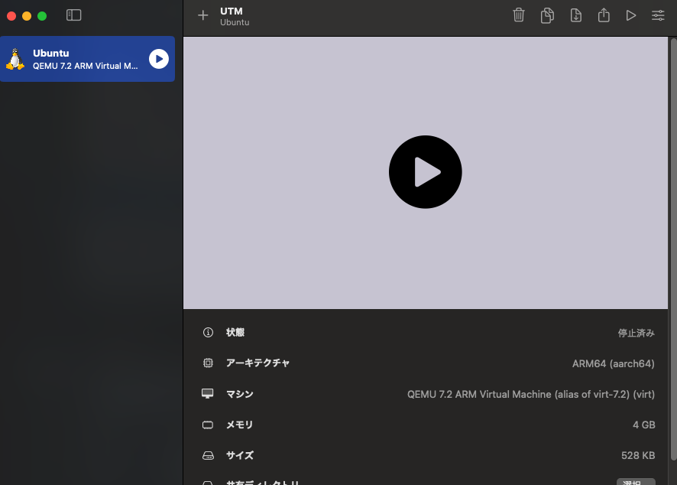

13. Confirm Ubuntu Boot

Verify that the virtual machine boots and displays the Ubuntu installation screen. Follow the installation instructions to complete the Ubuntu setup.

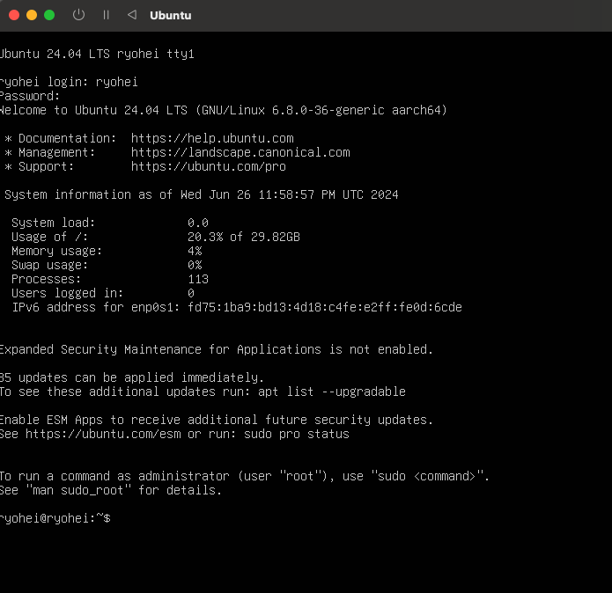

Word Count: 653

References

1. Silberschatz, A., Galvin, P. B., & Gagne, G. (2018).*Operating System Concepts* (10th ed.). John Wiley & Sons.
2. Tanenbaum, A. S., & Bos, H. (2015). *Modern Operating Systems* (4th ed.). Pearson.
3. Stallings, W. (2018). *Operating Systems: Internals and Design Principles* (9th ed.). Pearson.
4. William, S., & Sawyer, S. (2019). *Understanding Operating Systems* (8th ed.). Cengage Learning.